Subject line: You're invited to Horace Mann’s virtual speaker series!
After the year it’s been, who’s ready to hit the refresh button? We know you need a break ... and probably a little pick-me-up, so long-time CLAS corporate sponsor, Horace Mann, has put together an all-star cast of speakers who are ready to share their messages for educators and help you start 2021 off right.
Horace Mann invites you to step out of the presenter role, relax into the audience and recharge your batteries by joining our free virtual speaker series!
Today Show financial editor Jean Chatzky believes it’s completely possible to “create the lives we want, support the people we love and stress a little less.” Jean has made it her mission to simplify money matters by increasing financial literacy and will tell you the moves to make now to help ensure a life of financial comfort for you and your family.
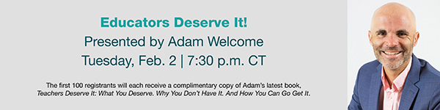
Who's been feeling overwhelmed and stressed lately? Adam Welcome has been a teacher, principal, Director of Innovation for a 35,000-student district and is now a best-selling author who believes kids deserve educators at their best. Adam’s energy, passion and new ideas will empower and motivate you to become the best version of yourself in the new year.
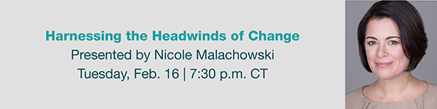
Col. Nicole Malachowski, USAF (Ret.), defies stereotypes as a combat veteran with a distinguished 21-year Air Force career. After prevailing against a tick-borne illness that left her struggling to speak or walk for almost nine months, Nicole will inspire you to rethink your challenges and urge you to go beyond resilience and become resurgent.
Save your spot
The speakers are not affiliated with Horace Mann Educators Corporation. The views and opinions expressed are those of the speakers and do not necessarily reflect the position of Horace Mann Educators Corporation or its subsidiary companies. Horace Mann’s Privacy Policy can be found here. For California residents, view Horace Mann’s California Consumer Privacy Notice.
CLAS has agreements with Horace Mann and affiliates (Horace Mann) where Horace Mann pays CLAS to provide various services that are aimed at familiarizing CLAS members with the Horace Mann brand, products or services.

EMI-00300 (Nov. 20)

