Who’s ready to hit the refresh button? We know you need a break ... and probably a little pick-me-up, so long-time CLAS corporate sponsor, Horace Mann, has put together an all-star cast of speakers who are ready to share their messages with you during their free Virtual Speaker Series for educators!
The series will feature Jean Chatzky, NBC’s Today Show financial editor, Adam Welcome, a former educator, principal and best-selling author and Col. Nicole Malachowski, USAF (Ret.), the first woman thunderbird pilot, a combat veteran, fighter squadron commander and White House Fellow and Adviser. Space is limited, so register soon.
http://authoring.horacemann.com/educatorsdeserve
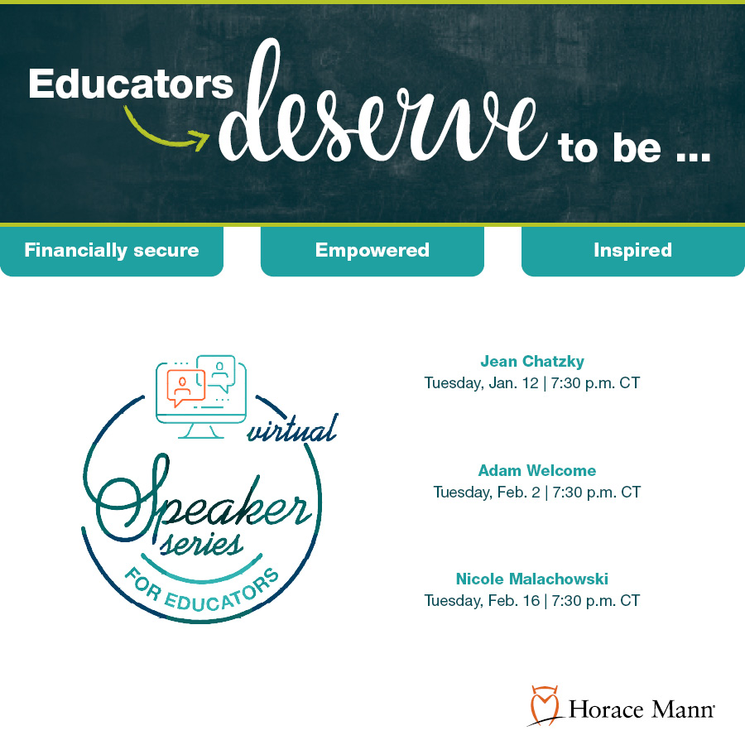
SM-X00215 (Dec. 20)

