Subject line: Ready to feel empowered?
Who's been feeling overwhelmed and stressed lately? Adam Welcome has been a teacher, principal, Director of Innovation for a 35,000-student district and is now a best-selling author who believes kids deserve educators at their best.
Adam’s energy, passion and new ideas will empower and motivate you to become the best version of yourself in the new year. Join us for this free event!
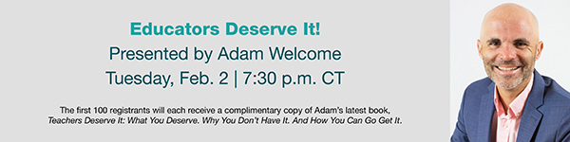
Save your spot
The speakers are not affiliated with Horace Mann Educators Corporation. The views and opinions expressed are those of the speakers and do not necessarily reflect the position of Horace Mann Educators Corporation or its subsidiary companies. Horace Mann’s Privacy Policy can be found here. For California residents, view Horace Mann’s California Consumer Privacy Notice.
CLAS has agreements with Horace Mann and affiliates (Horace Mann) where Horace Mann pays CLAS to provide various services that are aimed at familiarizing CLAS members with the Horace Mann brand, products or services.

EMI-00302 (Nov. 20)

